Project Report on
Movie Search Application
Minor Project
Integrated Master of Computer Application (IMCA)
By
Kashish More
0810CA21DD28
Semester -VI
Under the supervision of
Dr. Nazia Huassin

IPS Academy Indore
School of Computers
RAJIV GANDHI PROUDYOGIKI VISHWAVIDHYALAYA, BHOPAL 2024

CERTIFICATE

The is to certify that Kashish More 0810CA21DD28 of Integrated Master of Computer Application (IMCA), SOC IPS ACADEMY has successfully completed his Semester VI minor project entitled, Movie Search Application under the Guidance of Dr. Nazia Hussian a part of fulfillment of academic curriculum.

External Examiner Internal Examiner
Date Date

Director
IPS Academy Indore
School of Computers

Candidate’s Declaration

This is certified that work, which is being presented in the project entitled Movie Search Application submitted by undersigned student of final year MCA in partial fulfillment for the degree of Integrated Master of Computer Application (IMCA) is a record of our own work carried out by us under guidance and supervision of Dr. Nazia Hussian and school of computer.
This work has not been submitted elsewhere for award of any other degree.

Date: Name – Kashish More
Place: IPS Academy Signature of Student-
School of Computers, Indore

Acknowledgement

The satisfaction that accompanies that the successful completion of any task would be incomplete without the mention of people whose ceaseless corporation made it possible whose constant guidance and encouragement crown all efforts with success.
We are grateful to our guide Dr. Nazia Hussian for the guidance, inspiration and constructive suggestions that helpful us in preparation of this project.
We also thanks who have helped in successful completion of the project.

Date: Kashish More
Place: IPS Academy Indore 0810CA21DD28
IMCA- VI Sem

TABLE OF CONTENTS

Chapter No. | Title | Page No.
 | Certificate
 | Acknowledgement
 | Dissertation Approval Sheet
1  1.1  1.2  1.3  1.4  1.5  1.5.1  1.5.2  1.5.3 | Introduction  Introduction  Motivation  Objective  Proposed solution  Platform Specification  - Hardware specification  - Software specification  - Tools and technology
2  2.1  2.2  2.3 | Background and related work  Existing system  Proposed system  Comparative table
3  3.1  3.1.1  3.1.2  3.1.3  3.2  3.3 | System analysis and deign  Feasibility study  - Technical feasibility  - Economical feasibility  - Operational feasibility  Non-functional requirement  Functional requirement
4  4.1  4.2 | Design  ER Diagram  Data Flow Diagram
5  5.1  5.2  5.3  5.4 | Implementation  Implementation  History and feature  Application  Screenshots with detail
6  6.1  6.2  7  7.1  7.2 | Testing  Test steps  Test case  Database description  List of tables  Structure of table
8  8.1  8.2  8.3 | Conclusion and Discussion  Conclusion and Discussion  Future Scope of the Project  References
- INTRODUCTION

  - Introduction
The Movie Search Application is a web-based platform designed to provide users with quick access to movie information. By utilizing the OMDb (Open Movie Database) API, the application retrieves and displays data such as movie titles, posters, release years, genres, directors, and plots. This project employs HTML, CSS, and JavaScript for its front-end implementation, ensuring a dynamic and user-friendly interface.
  - Motivation
The motivation behind this project is to simplify the process of finding movie information. With the vast number of movies available, it can be time-consuming to search for details across multiple websites. This application aims to consolidate movie data in one place, providing a seamless and efficient user experience.

  - Objective
The primary objective of this project is to develop an interactive web application that allows users to search for movies and view detailed information about them. The application should be intuitive, responsive, and able to handle multiple search queries effectively.
  - Proposed Solution
The proposed solution involves creating a web application that integrates with the OMDb API to fetch and display movie information. Users can enter a movie title in the search bar, and the application will display a list of matching movies. Clicking on a movie will show detailed information about it. A back button will allow users to return to the search results for further browsing.
  - Platform Specification

    - Hardware Specification:
- Processor: Intel Core i3 or higher
- RAM: 4GB or more
- Storage: 10GB free space
- Internet connection for API access
    - Software Specification:
- Operating System: Windows, macOS, or Linux
- Web Browser: Google Chrome, Mozilla Firefox, or any modern browser
    - Tools and technologies:
- HTML: Structure of the web application
- CSS: Styling the application
- JavaScript: Dynamic behavior and API interactions
- OMDb API: Data source for movie information

2. Background and Related Work

2.1 Existing System
Existing systems include various movie databases and websites like IMDb and Rotten Tomatoes. These platforms provide extensive movie information but can be complex and cluttered, making it difficult for users to find specific information quickly.

2.2 Proposed System
The proposed system offers a simplified interface focused on movie searches. It fetches data from the OMDb API and displays it in a clean, user-friendly manner. The application is designed to be lightweight and responsive, ensuring a smooth user experience.

2.3 Comparative Table
Feature | Existing Systems (IMDb, etc.) | Proposed System
User Interface | Complex and cluttered | Simple and clean
Data Source | Extensive databases | OMDb API
Search Functionality | Advanced search options | Basic search
Responsiveness | Varies | Highly responsive
Ease of Use | Moderate | High

3. System Analysis and Design
3.1 Feasibility Study:
3.1.1 Technical Feasibility:
The project is technically feasible as it uses widely supported web technologies (HTML, CSS, JavaScript) and a reliable API (OMDb). The required skills and tools are readily available.
3.1.2 Economical Feasibility:
The project is economically feasible. The main costs involve the development time and a potential subscription for a higher rate limit on the OMDb API if required.
3.1.3 Operational Feasibility:
The project is operationally feasible. The application can be deployed on any standard web server, and users only need a web browser to access it.

  - Non-functional requirements :
- Usability: The application should be easy to use for people of all ages.
- Performance: The application should load quickly and handle multiple requests efficiently.
- Reliability: The application should reliably fetch and display accurate data from the OMDb API.
- Scalability: The application should be able to handle increased traffic and data load.
  - Functional Requirements:
- Search Function: Allow users to search for movies by title.
- Display Results: Show a list of movies matching the search query.

- Show Details: Display detailed information about a selected movie.

- Back Function: Provide a button to return to the search results.

- Design

4.1 ER Diagram
Since this project does not involve a database, an ER Diagram is not applicable.
4.2 Data Flow Diagram
The Data Flow Diagram (DFD) illustrates the flow of information within the application:
- User Input: User enters a movie title in the search bar.
- API Request: Application sends a request to the OMDb API.
- API Response: OMDb API returns movie data.
- Display Results: Application displays the search results.
- View Details: User clicks on a movie to view detailed information.
- Back to Results: User clicks the back button to return to the search results.

5. Implementation
5.1 Implementation:
The implementation involves coding the front-end using HTML, CSS, and JavaScript. The OMDb API is integrated to fetch movie data. The project is structured into three main components: the search form, the movie list, and the movie details section.
5.2 History and Feature:
- History: The OMDb API was chosen for its comprehensive movie database and ease of use. The application was developed to provide a user-friendly interface for movie searches.
- Features:
- Search for movies by title.
- Display a list of matching movies.
- Show detailed information about a selected movie.
- Provide a back button to return to search results.
5.3 Applications

The application can be used by movie enthusiasts, researchers, and anyone interested in finding information about movies quickly and efficiently.

5.4 Screen shots
Including screenshots of the application with annotations explaining each part:
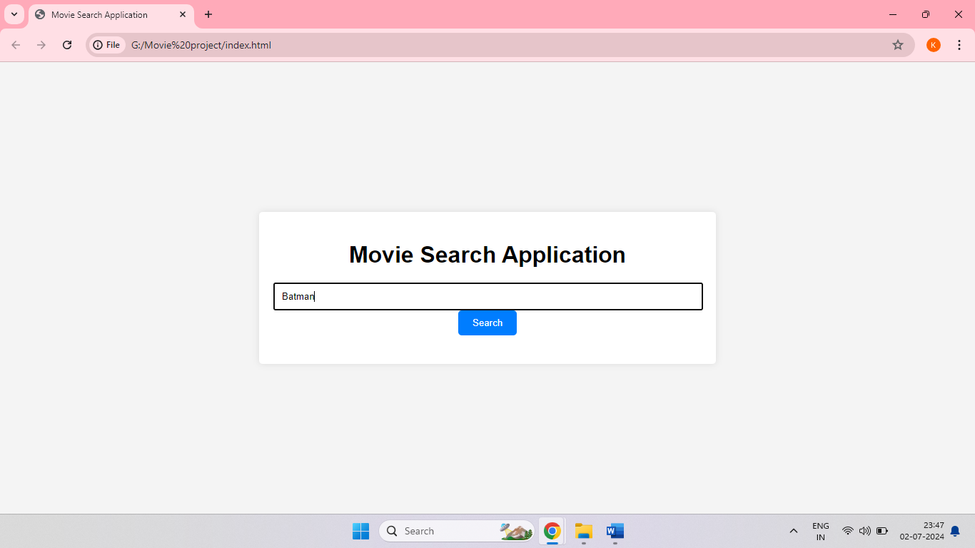
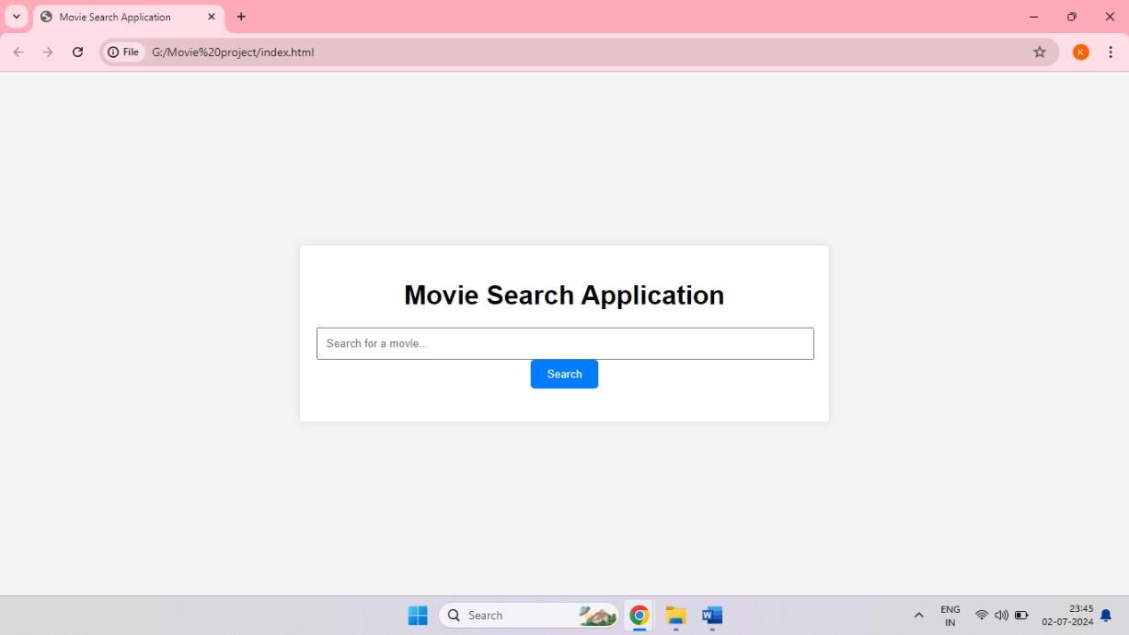
Search Page: Showing the search bar and button.

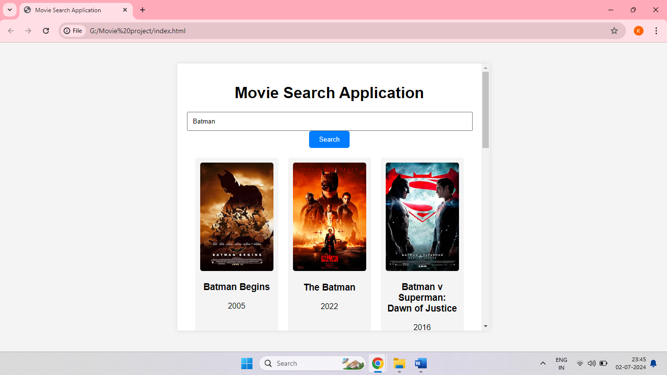
- Search Results: Displaying a list of movies.

- Movie Details: Showing detailed information about a selected movie
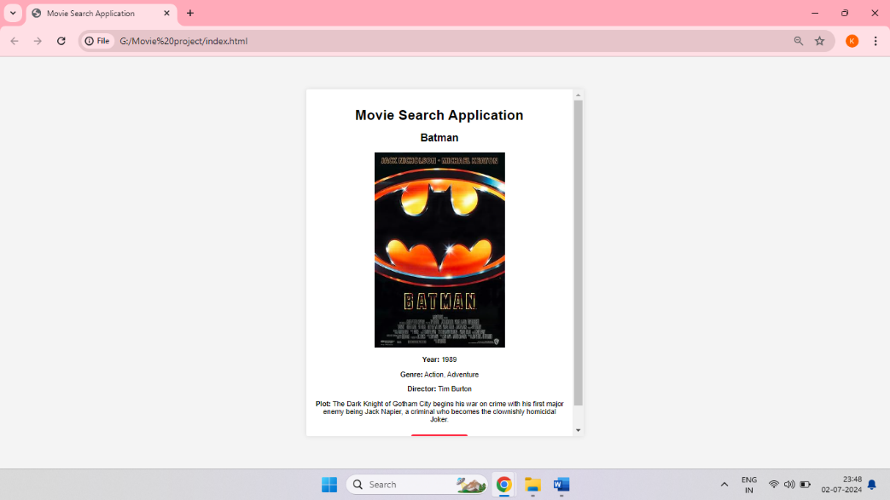

- Back Button: Allowing users to return to search results
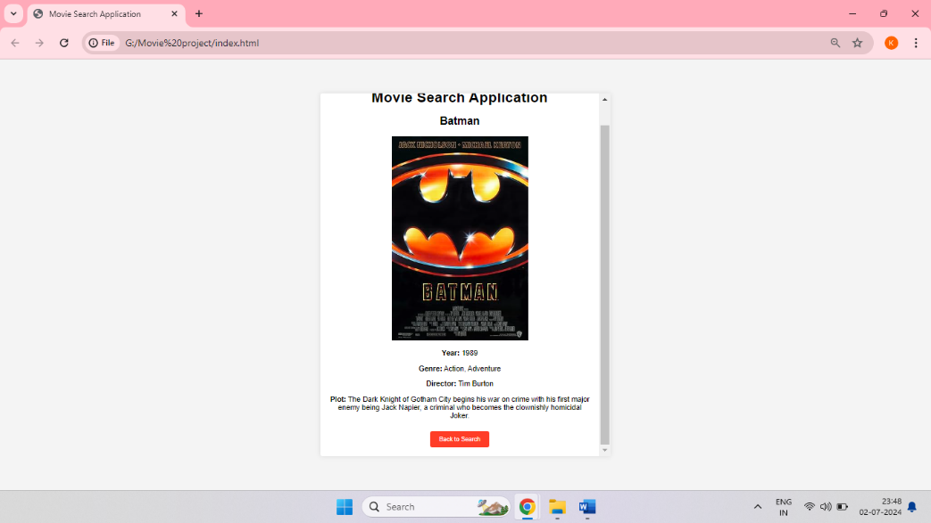

6. Testing
6.1 Test Steps
- Open the application in a web browser.
- Enter a movie title in the search bar.
- Click the search button.
- Verify that the search results are displayed correctly.
- Click on a movie to view details.
- Verify that the movie details are displayed correctly.
- Click the back button to return to the search results.
- Verify that the search results are displayed again.
6.2 Test case:
Test Case | Input | Expected Output | Status
Search Functionality | "Batman" | Display a list of Batman movies | Pass
View Movie Details | Click on movie | Display detailed information about the movie | Pass
Back Button Function | Click Back | Return to the search results | Pass

7. Database Description :
7.1 List of Tables:
Not applicable as this project does not involve a database.
7.2 Table Structure:
Not applicable as this project does not involve a database.

8. Conclusion and Discussion
8.1 Conclusion and Discussion
The Movie Search Application successfully meets its objectives by providing a user-friendly platform for searching and viewing movie information. The integration with the OMDb API allows for comprehensive and accurate data retrieval. The project demonstrates effective use of HTML, CSS, and JavaScript in developing a responsive and interactive web application.
8.2 Future scope of project-
- Enhanced UI/UX: Improve the user interface with advanced CSS frameworks.
- Additional Features: Add user ratings, reviews, and recommendations.
- Mobile Optimization: Ensure full responsiveness and optimization for mobile devices.
- Caching: Implement caching to reduce API calls and improve performance.
- Security Enhancements: Protect API keys and user data more robustly.
8.3 References:
- www.google.com
- http://slideshare
- http://w3school
- OMDb API Documentation: OMDb API

8.4 Bibliography:
The content for this project report has been taken from following sources:
- https://academia.edu
- https://freeprojectz.com
- https://slideshare.net
- www.google.com

